**Amazon Sale Report**

**Research Question**

1. Finding most people buying products
2. Check Courier Status
3. Check B2B Order Status
4. Check B2C Order Status
5. Finding Lowest Sale Products
6. Finding Top 10 Cities

**Analysis and Findings**

1. Most people buying clothing M size t-shirt

Biggest sale T-shirt size in M in 6806

Lowest sale T-shirt size in 4XL in 104 only

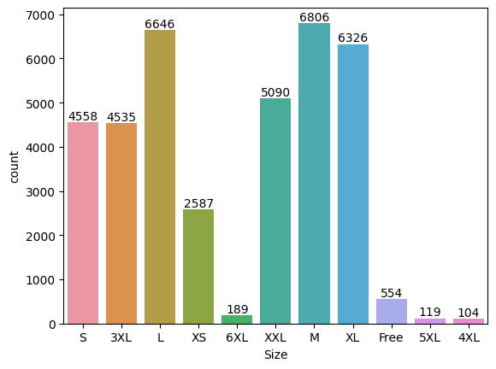

1. Most Quantity buying M size

Most Quantity sale in M Size 5905

Lowest Quantity sale in 4XL Size 93

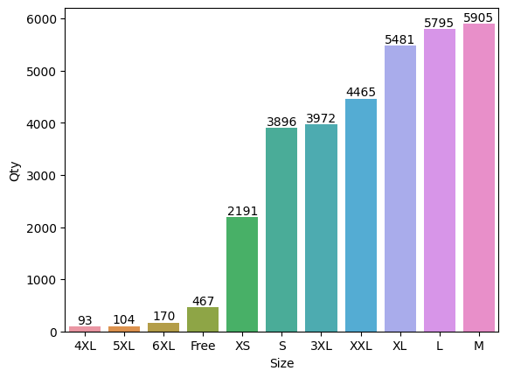

1. Courier Status

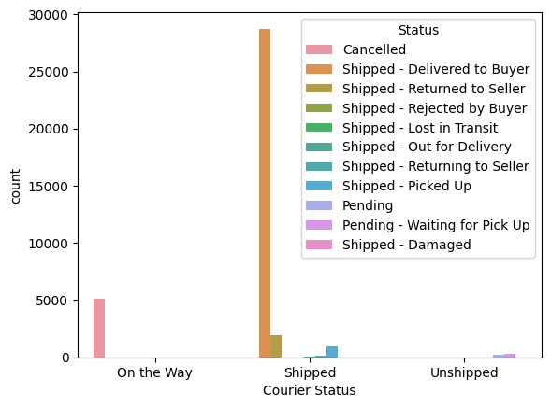

1. Biggest sale Products

Highest Product Sale in T-Shirt

Lowest Product Sale in Shoes

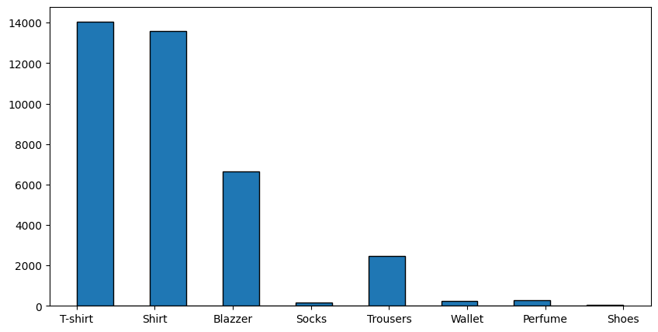

1. Check B2B Data

The false part is the B2C cell

And True Part is the B2B Cell

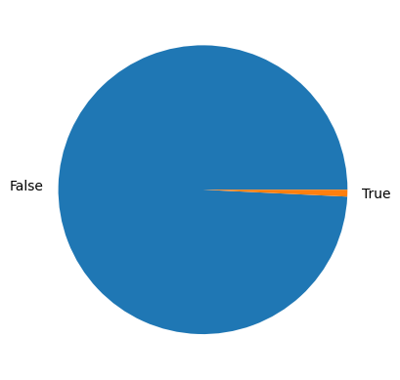

1. Top 10 State

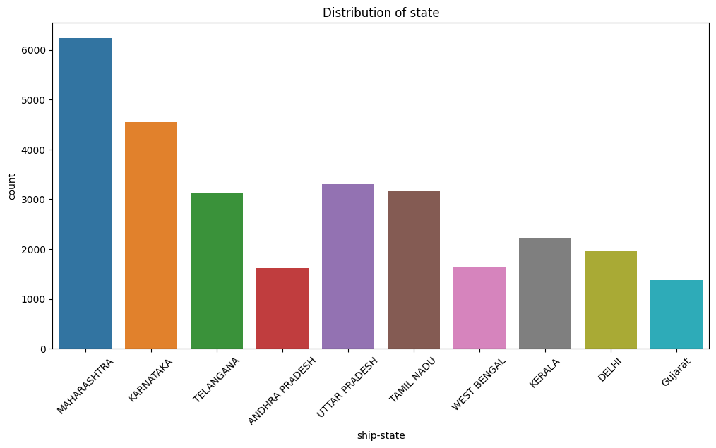

**How to Increase Revenue ?**

1. Increase sale
   * + - 1. Increase Shoes Sale
         2. Increase Shocks Sale
         3. Increase Wallet Sale
         4. Increase Perfume Sale
2. Management Courier Service
   * + 1. Fast Delivery
       2. Manage Order Cancellation
       3. Manage Product Damages
3. Market research